**CIS 3270 Final Group Project Documentation**

**Team member:**

**Jiayi Tian**

**Kun Zhou**

1- Briefly explains requirements and specification of the project

2- Showing the class diagram using UML

3- Showing the Data Model (Tables and all the PKs and FKs)

4- Briefly explains about functionality and flow of the program

Introduction (byJiayi Tian):

The project is to simulate an airline reservation system by using java eclipse. There are two types of user for this system, customers and admins. Customer could search flight information and book flight-ticket through this system. Admins could do same things as customers but has more privileges, such as adding or deleting flights. New customers should register first before logging in their account. Upon logging in, if customers forget their password, they could find their password back by answering security questions. After their logged in their account, their previous booked flight information should be there in his/her account. On the main menu, users could do certain activities by entering corresponse numbers. The activities include searching flights by departure and arrival cities, booking flight tickets, checking booked information, and all flight information. In any case they could go back to the main menu and make a new selection.

Data Model (Tables and all the PKs and FKs)

MySQL ERD table (by Jiayi Tian):

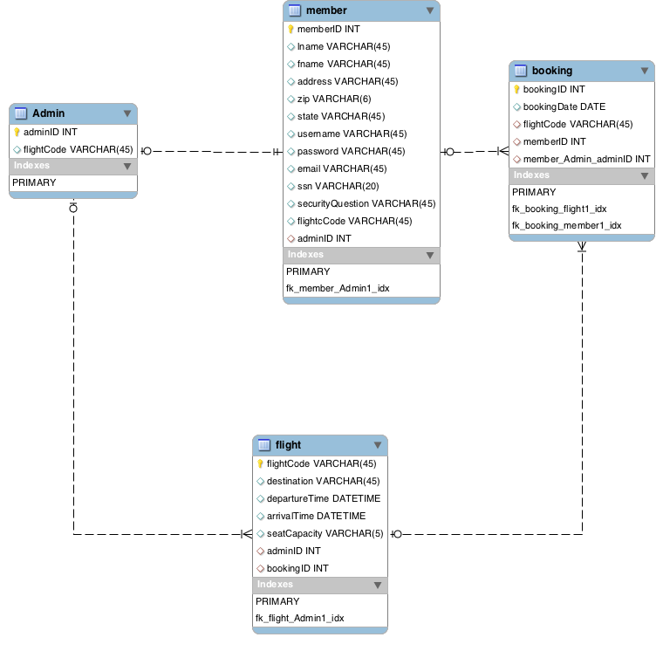

UML tables (by Kun Zhou):

(Admin table extends User table)

: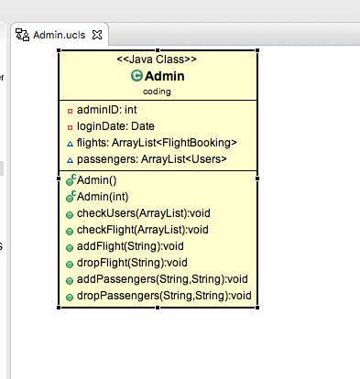

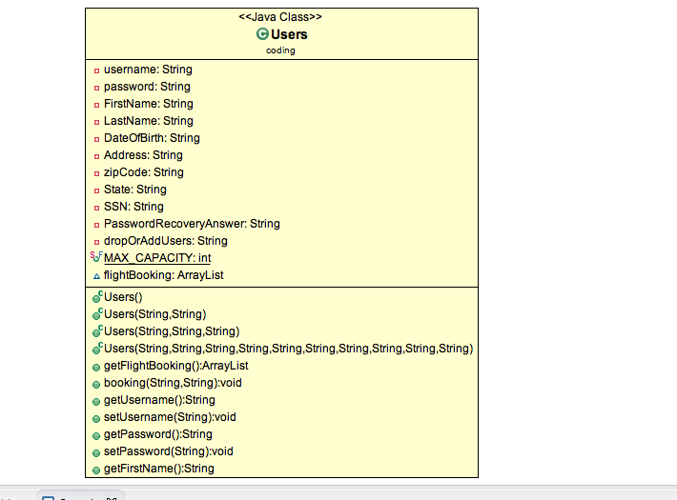

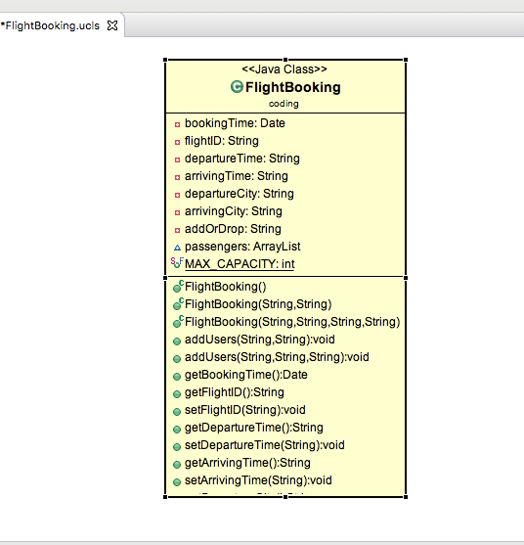

MySQL script:

-- MySQL Script generated by MySQL Workbench

-- Mon Apr 24 19:53:44 2017

-- Model: New Model Version: 1.0

-- MySQL Workbench Forward Engineering

SET @OLD_UNIQUE_CHECKS=@@UNIQUE_CHECKS, UNIQUE_CHECKS=0;

SET @OLD_FOREIGN_KEY_CHECKS=@@FOREIGN_KEY_CHECKS, FOREIGN_KEY_CHECKS=0;

SET @OLD_SQL_MODE=@@SQL_MODE, SQL_MODE='TRADITIONAL,ALLOW_INVALID_DATES';

-- -----------------------------------------------------

-- Schema airlineReservationDB

-- -----------------------------------------------------

-- CIS3270 Final Group Project

-- -----------------------------------------------------

-- Schema airlineReservationDB

--

-- CIS3270 Final Group Project

-- -----------------------------------------------------

CREATE SCHEMA IF NOT EXISTS `airlineReservationDB` DEFAULT CHARACTER SET utf8 ;

USE `airlineReservationDB` ;

-- -----------------------------------------------------

-- Table `airlineReservationDB`.`Admin`

-- -----------------------------------------------------

CREATE TABLE IF NOT EXISTS `airlineReservationDB`.`Admin` (

`adminID` INT NOT NULL AUTO_INCREMENT,

`flightCode` VARCHAR(45) NULL,

PRIMARY KEY (`adminID`))

ENGINE = InnoDB

COMMENT = 'Admin is subclass of Member';

-- -----------------------------------------------------

-- Table `airlineReservationDB`.`member`

-- -----------------------------------------------------

CREATE TABLE IF NOT EXISTS `airlineReservationDB`.`member` (

`memberID` INT NOT NULL AUTO_INCREMENT,

`lname` VARCHAR(45) NULL,

`fname` VARCHAR(45) NULL,

`address` VARCHAR(45) NULL,

`zip` VARCHAR(6) NULL,

`state` VARCHAR(45) NULL,

`username` VARCHAR(45) NULL,

`password` VARCHAR(45) NULL,

`email` VARCHAR(45) NULL,

`ssn` VARCHAR(20) NULL,

`securityQuestion` VARCHAR(45) NULL,

`flightcCode` VARCHAR(45) NULL,

`adminID` INT NULL,

PRIMARY KEY (`memberID`),

INDEX `fk_member_Admin1_idx` (`adminID` ASC),

CONSTRAINT `fk_member_Admin1`

FOREIGN KEY (`adminID`)

REFERENCES `airlineReservationDB`.`Admin` (`adminID`)

ON DELETE NO ACTION

ON UPDATE NO ACTION)

ENGINE = InnoDB;

-- -----------------------------------------------------

-- Table `airlineReservationDB`.`flight`

-- -----------------------------------------------------

CREATE TABLE IF NOT EXISTS `airlineReservationDB`.`flight` (

`flightCode` VARCHAR(45) NOT NULL,

`destination` VARCHAR(45) NULL,

`departureTime` DATETIME NULL,

`arrivalTime` DATETIME NULL,

`seatCapacity` VARCHAR(5) NULL,

`adminID` INT NULL,

`bookingID` INT NULL,

PRIMARY KEY (`flightCode`),

INDEX `fk_flight_Admin1_idx` (`adminID` ASC, `bookingID` ASC),

CONSTRAINT `fk_flight_Admin1`

FOREIGN KEY (`adminID` , `bookingID`)

REFERENCES `airlineReservationDB`.`Admin` (`adminID` , `flightCode`)

ON DELETE NO ACTION

ON UPDATE NO ACTION)

ENGINE = InnoDB;

-- -----------------------------------------------------

-- Table `airlineReservationDB`.`booking`

-- -----------------------------------------------------

CREATE TABLE IF NOT EXISTS `airlineReservationDB`.`booking` (

`bookingID` INT NOT NULL AUTO_INCREMENT,

`bookingDate` DATE NULL,

`flightCode` VARCHAR(45) NULL,

`memberID` INT NULL,

`member_Admin_adminID` INT NULL,

PRIMARY KEY (`bookingID`),

INDEX `fk_booking_flight1_idx` (`flightCode` ASC),

INDEX `fk_booking_member1_idx` (`memberID` ASC, `member_Admin_adminID` ASC),

CONSTRAINT `fk_booking_flight1`

FOREIGN KEY (`flightCode`)

REFERENCES `airlineReservationDB`.`flight` (`flightCode`)

ON DELETE NO ACTION

ON UPDATE NO ACTION,

CONSTRAINT `fk_booking_member1`

FOREIGN KEY (`memberID` , `member_Admin_adminID`)

REFERENCES `airlineReservationDB`.`member` (`memberID` , `adminID`)

ON DELETE NO ACTION

ON UPDATE NO ACTION)

ENGINE = InnoDB;

SET SQL_MODE=@OLD_SQL_MODE;

SET FOREIGN_KEY_CHECKS=@OLD_FOREIGN_KEY_CHECKS;

SET UNIQUE_CHECKS=@OLD_UNIQUE_CHECKS;

CREATE DATABASE IF NOT EXISTS `airlineReservationDB` /*!40100 DEFAULT CHARACTER SET utf8 */;

USE `airlineReservationDB`;

-- MySQL dump 10.13 Distrib 5.7.17, for macos10.12 (x86_64)

--

-- Host: 127.0.0.1 Database: airlineReservationDB

-- ------------------------------------------------------

-- Server version 5.7.18

/*!40101 SET @OLD_CHARACTER_SET_CLIENT=@@CHARACTER_SET_CLIENT */;

/*!40101 SET @OLD_CHARACTER_SET_RESULTS=@@CHARACTER_SET_RESULTS */;

/*!40101 SET @OLD_COLLATION_CONNECTION=@@COLLATION_CONNECTION */;

/*!40101 SET NAMES utf8 */;

/*!40103 SET @OLD_TIME_ZONE=@@TIME_ZONE */;

/*!40103 SET TIME_ZONE='+00:00' */;

/*!40014 SET @OLD_UNIQUE_CHECKS=@@UNIQUE_CHECKS, UNIQUE_CHECKS=0 */;

/*!40014 SET @OLD_FOREIGN_KEY_CHECKS=@@FOREIGN_KEY_CHECKS, FOREIGN_KEY_CHECKS=0 */;

/*!40101 SET @OLD_SQL_MODE=@@SQL_MODE, SQL_MODE='NO_AUTO_VALUE_ON_ZERO' */;

/*!40111 SET @OLD_SQL_NOTES=@@SQL_NOTES, SQL_NOTES=0 */;

--

-- Table structure for table `Admin`

--

DROP TABLE IF EXISTS `Admin`;

/*!40101 SET @saved_cs_client = @@character_set_client */;

/*!40101 SET character_set_client = utf8 */;

CREATE TABLE `Admin` (

`adminID` int(11) NOT NULL AUTO_INCREMENT,

`flightCode` varchar(45) DEFAULT NULL,

PRIMARY KEY (`adminID`)

) ENGINE=InnoDB AUTO_INCREMENT=40 DEFAULT CHARSET=utf8 COMMENT='Admin is subclass of Member';

/*!40101 SET character_set_client = @saved_cs_client */;

--

-- Dumping data for table `Admin`

--

LOCK TABLES `Admin` WRITE;

/*!40000 ALTER TABLE `Admin` DISABLE KEYS */;

INSERT INTO `Admin` VALUES (35,'FM2384'),(36,'HI7329'),(37,'NG3827'),(38,'MY3846'),(39,'GO3874');

/*!40000 ALTER TABLE `Admin` ENABLE KEYS */;

UNLOCK TABLES;

--

-- Table structure for table `booking`

--

DROP TABLE IF EXISTS `booking`;

/*!40101 SET @saved_cs_client = @@character_set_client */;

/*!40101 SET character_set_client = utf8 */;

CREATE TABLE `booking` (

`bookingID` int(11) NOT NULL AUTO_INCREMENT,

`bookingDate` date DEFAULT NULL,

`memberID` int(11) DEFAULT NULL,

`flightCode` varchar(45) DEFAULT NULL,

PRIMARY KEY (`bookingID`),

KEY `fk_memberID_idx` (`memberID`),

CONSTRAINT `fk_memberID` FOREIGN KEY (`memberID`) REFERENCES `member` (`memberID`) ON DELETE NO ACTION ON UPDATE NO ACTION

) ENGINE=InnoDB AUTO_INCREMENT=140 DEFAULT CHARSET=utf8;

/*!40101 SET character_set_client = @saved_cs_client */;

--

-- Dumping data for table `booking`

--

LOCK TABLES `booking` WRITE;

/*!40000 ALTER TABLE `booking` DISABLE KEYS */;

INSERT INTO `booking` VALUES (135,'2017-04-03',1,'FM2384'),(136,'2017-04-09',2,'HI7329'),(137,'2017-04-17',3,'NG3827'),(138,'2017-03-27',4,'MY3846'),(139,'2017-05-01',5,'GO3874');

/*!40000 ALTER TABLE `booking` ENABLE KEYS */;

UNLOCK TABLES;

--

-- Table structure for table `flight`

--

DROP TABLE IF EXISTS `flight`;

/*!40101 SET @saved_cs_client = @@character_set_client */;

/*!40101 SET character_set_client = utf8 */;

CREATE TABLE `flight` (

`flightCode` varchar(45) NOT NULL,

`destination` varchar(45) DEFAULT NULL,

`departureTime` datetime DEFAULT NULL,

`arrivalTime` datetime DEFAULT NULL,

`seatCapacity` varchar(45) DEFAULT NULL,

`bookingID` int(11) DEFAULT NULL,

PRIMARY KEY (`flightCode`),

KEY `fk_bookingID_idx` (`bookingID`),

CONSTRAINT `fk_bookingID` FOREIGN KEY (`bookingID`) REFERENCES `booking` (`bookingID`) ON DELETE NO ACTION ON UPDATE NO ACTION

) ENGINE=InnoDB DEFAULT CHARSET=utf8;

/*!40101 SET character_set_client = @saved_cs_client */;

--

-- Dumping data for table `flight`

--

LOCK TABLES `flight` WRITE;

/*!40000 ALTER TABLE `flight` DISABLE KEYS */;

INSERT INTO `flight` VALUES ('FM2384','Los Angeles','2017-04-24 15:00:00','2017-04-24 19:00:00','5',136),('GO3874','Detroid','2017-05-13 08:20:00','2017-05-13 10:30:00','5',137),('HI7329','New York','2017-05-18 13:00:00','2017-05-18 17:20:00','5',138),('MY3846','Orlando','2017-05-22 11:30:00','2017-05-22 14:15:00','5',139),('NG3827','Atlanta','2017-04-29 10:00:00','2017-04-29 15:15:00','5',135);

/*!40000 ALTER TABLE `flight` ENABLE KEYS */;

UNLOCK TABLES;

--

-- Table structure for table `member`

--

DROP TABLE IF EXISTS `member`;

/*!40101 SET @saved_cs_client = @@character_set_client */;

/*!40101 SET character_set_client = utf8 */;

CREATE TABLE `member` (

`memberID` int(11) NOT NULL AUTO_INCREMENT,

`lname` varchar(45) DEFAULT NULL,

`fname` varchar(45) DEFAULT NULL,

`address` varchar(45) DEFAULT NULL,

`zip` varchar(6) DEFAULT NULL,

`state` varchar(45) DEFAULT NULL,

`username` varchar(45) DEFAULT NULL,

`password` varchar(45) DEFAULT NULL,

`email` varchar(45) DEFAULT NULL,

`ssn` varchar(20) DEFAULT NULL,

`securityQuestion` varchar(45) DEFAULT NULL,

`flightcCode` varchar(45) DEFAULT NULL,

`adminID` int(11) DEFAULT NULL,

PRIMARY KEY (`memberID`),

KEY `fk_member_Admin1_idx` (`adminID`),

CONSTRAINT `fk_member_Admin1` FOREIGN KEY (`adminID`) REFERENCES `Admin` (`adminID`) ON DELETE NO ACTION ON UPDATE NO ACTION

) ENGINE=InnoDB AUTO_INCREMENT=6 DEFAULT CHARSET=utf8;

/*!40101 SET character_set_client = @saved_cs_client */;

--

-- Dumping data for table `member`

--

LOCK TABLES `member` WRITE;

/*!40000 ALTER TABLE `member` DISABLE KEYS */;

INSERT INTO `member` VALUES (1,'Steve','Smith','132 Liberty ','30293','GA','ss','123','ejf@gmail.com','394857','favorate song?','lie',35),(2,'Kim','Kelly','345 S. parkway NW','30284','CA','ert','5656','fe@gmail.com','459683722','first car?','toyota',36),(3,'Marry','Jone','23 Bolton Way','30482','MI','trt','rgr4','eree!gmail.com','456398294','favorate movie?','Rings',37),(4,'Sarah','Orian','64 Marietta Pkwy','30060','GA','way','dfdi3','ss@gmail.com','384957822','driver liscense?','3487598458',38),(5,'David','Liu','34 Main St','34028','FL','dimg','343o8','dds@gmail.com','392846722','pet name','ketty',39);

/*!40000 ALTER TABLE `member` ENABLE KEYS */;

UNLOCK TABLES;

/*!40103 SET TIME_ZONE=@OLD_TIME_ZONE */;

/*!40101 SET SQL_MODE=@OLD_SQL_MODE */;

/*!40014 SET FOREIGN_KEY_CHECKS=@OLD_FOREIGN_KEY_CHECKS */;

/*!40014 SET UNIQUE_CHECKS=@OLD_UNIQUE_CHECKS */;

/*!40101 SET CHARACTER_SET_CLIENT=@OLD_CHARACTER_SET_CLIENT */;

/*!40101 SET CHARACTER_SET_RESULTS=@OLD_CHARACTER_SET_RESULTS */;

/*!40101 SET COLLATION_CONNECTION=@OLD_COLLATION_CONNECTION */;

/*!40111 SET SQL_NOTES=@OLD_SQL_NOTES */;

-- Dump completed on 2017-04-24 22:54:46